Table of Contents
Catalog
Table of Contents 1
Read Me 2
Jira Setup & Overview (PRIMARY TOOL) 3
Part 1: Create Jira Service Management Project 3
Part 2: Core Jira Concepts (Basic) 5
Part 3: Default Workflow 7
Part 4: Submit Test Tickets in Jira 8
Part 5: Working a Ticket (Technician Flow) 9
Part 1:Setup & Overview of Spiceworks 10
Part 2: Configuration & Settings Overview 12
Part 3: Submitting Test Tickets 16
Part 4: Help Desk Technician Guide 20
Part 5: Help Desk & Ticket Management Cheat Sheet 23
Part 6: Wrap-Up & Key Takeaways 25

Read Me

Overview
This project demonstrates the setup and operation of a cloud-based IT help desk using Jira Service Management as the primary ticketing platform, with Spiceworks and Freshdesk included for comparison and additional exposure. It simulates a real-world IT support environment and covers the full ticket lifecycle, from request submission to resolution and closure.
The lab focuses on core help desk functions such as ticket creation, categorization, prioritization, technician workflows, user communication, escalation, and documentation. Users gain hands-on experience working with industry-standard tools and workflows commonly used in corporate IT and MSP environments.

Goals & Objectives
The goal of this project is to build practical, job-ready help desk skills while demonstrating familiarity with modern ticketing systems and IT support best practices. By completing this lab, you will be able to:

- Configure and operate Jira Service Management, including projects, issue types, workflows, queues, and ticket assignments.
- Understand and apply ticket workflows, statuses, and priority levels to manage support requests efficiently.
- Submit, track, and resolve tickets using multiple methods (portal, email, and technician-created tickets).
- Perform structured troubleshooting across hardware, software, network, and access-related issues.
- Communicate clearly with users, document actions accurately, and use internal notes for collaboration.
- Identify when to escalate issues based on impact, scope, security, or access limitations.
- Monitor ticket activity using dashboards and basic reporting to understand trends and workload.

This project serves as both a learning lab and a professional reference, showcasing foundational technical skills, operational awareness, and communication practices expected in entry-level IT support and help desk roles.

Jira Setup & Overview (PRIMARY TOOL)

Purpose
Jira Service Management is the primary ticketing system in this lab. This section demonstrates basic setup, ticket flow, and technician actions commonly used in corporate IT environments.

Part 1: Create Jira Service Management Project
- Create a free Atlassian account.
- Select Jira Service Management.
- Create a Service Desk project.
- Name it: IT Help Desk Lab.

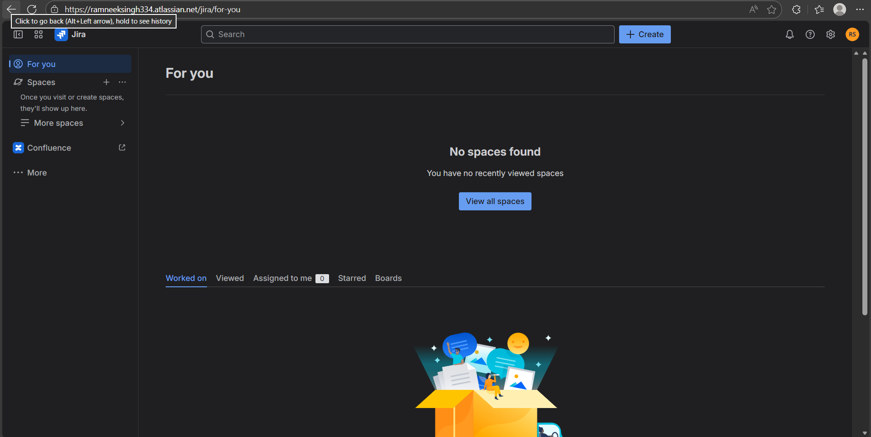
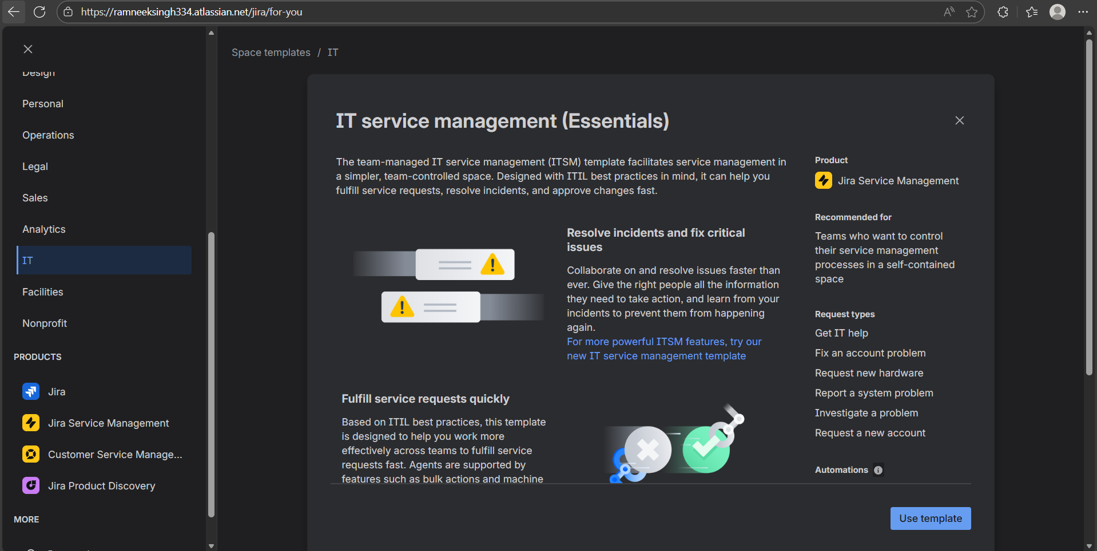
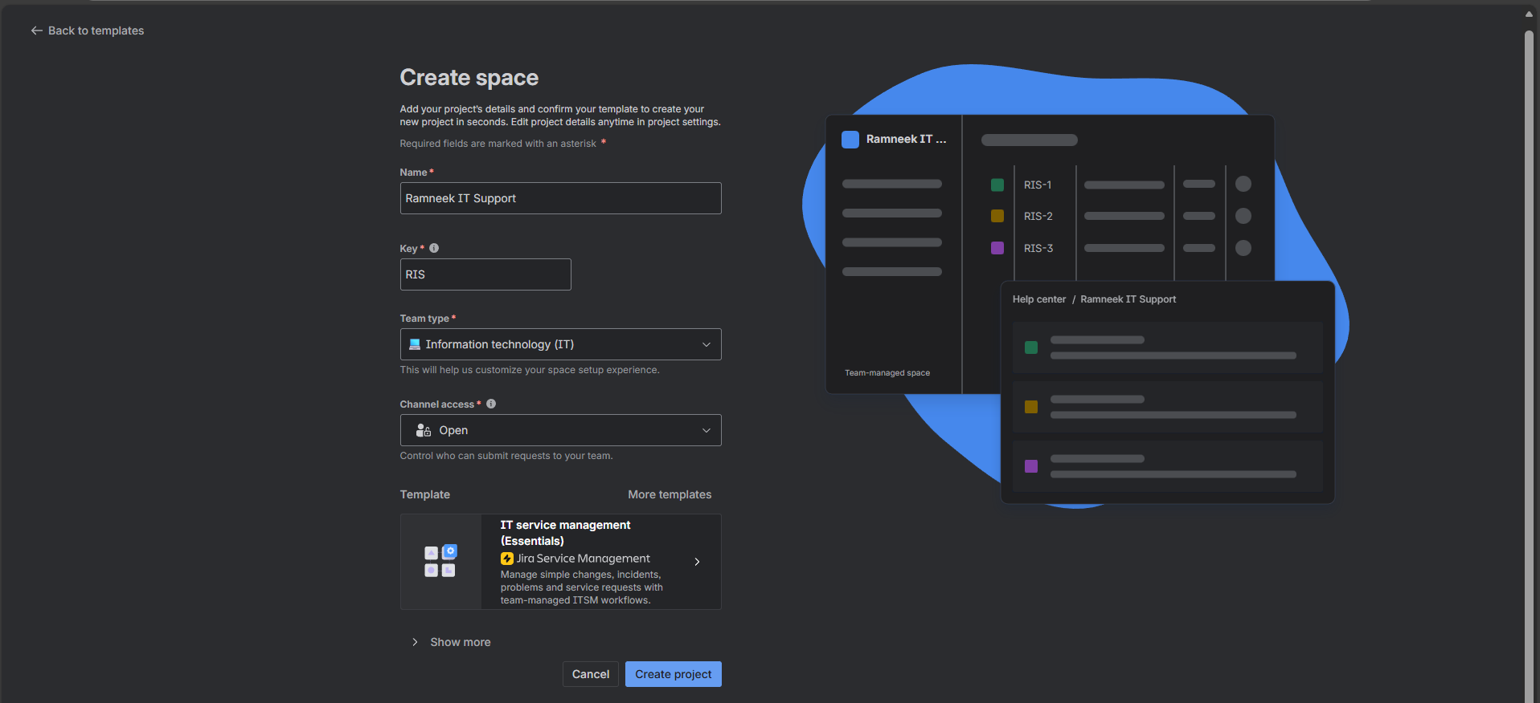

Part 2: Core Jira Concepts (Basic)
- Issue = Ticket
- Project = Help Desk
- Agent = Technician
- Customer = End User
- Queue = Ticket list
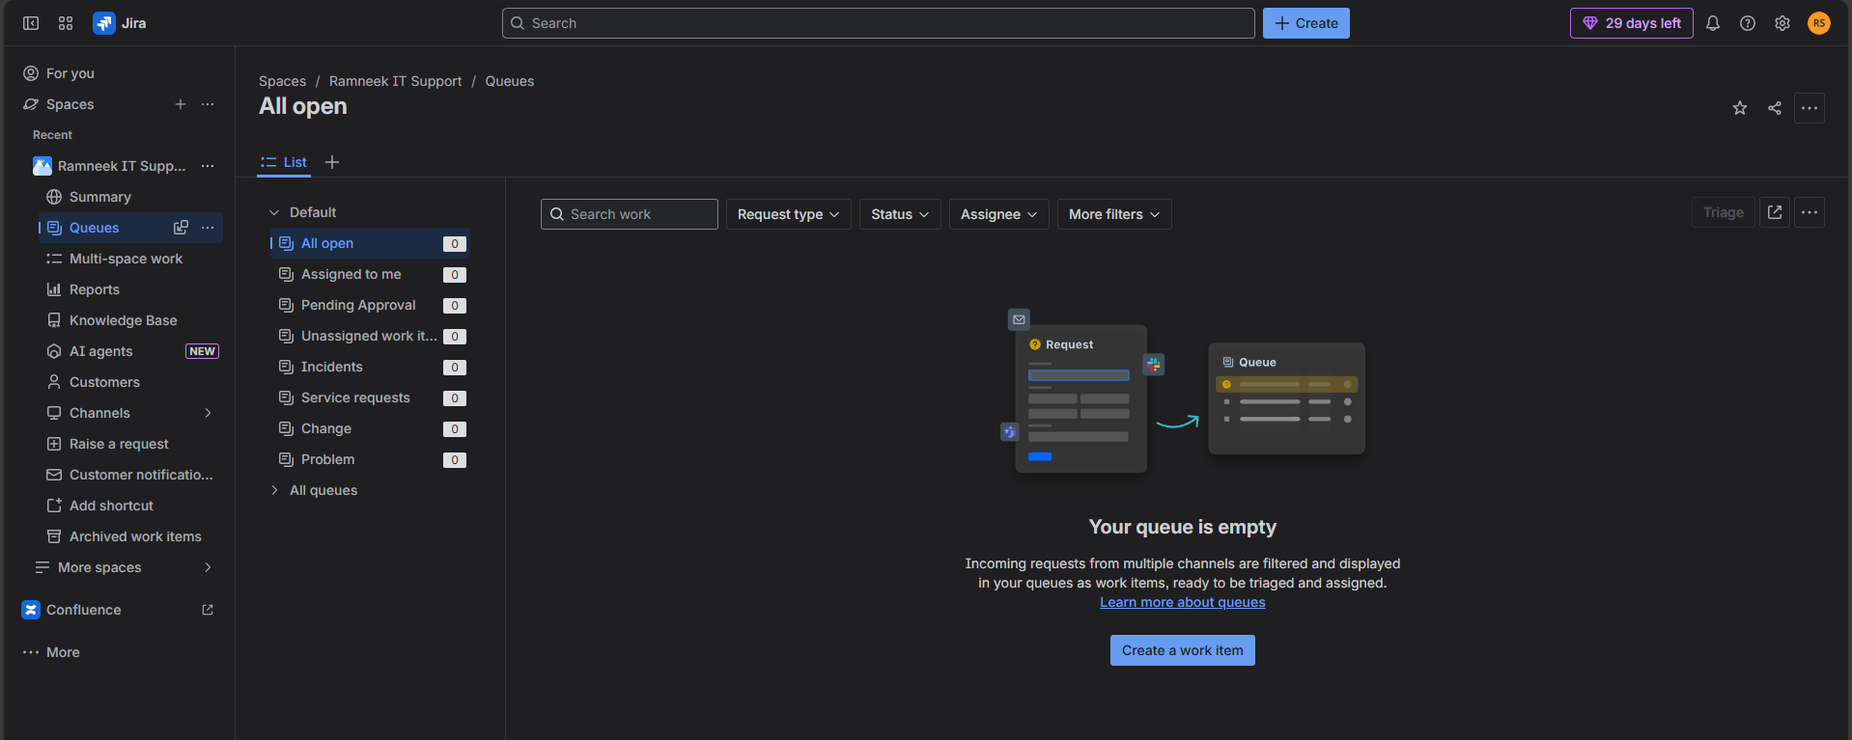
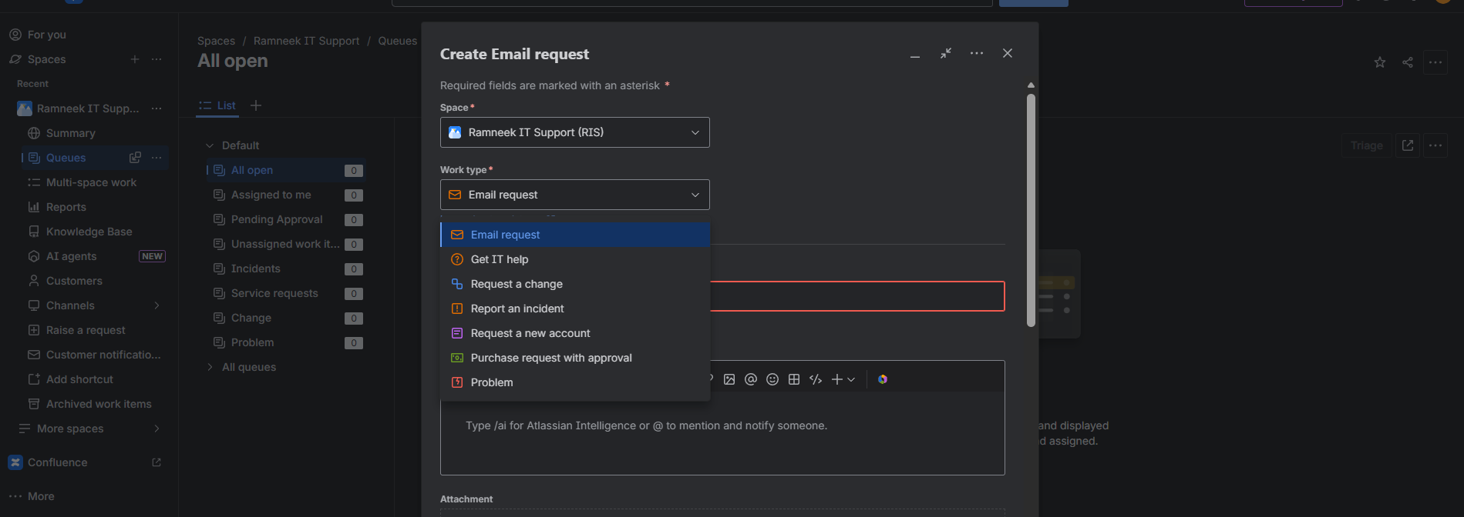
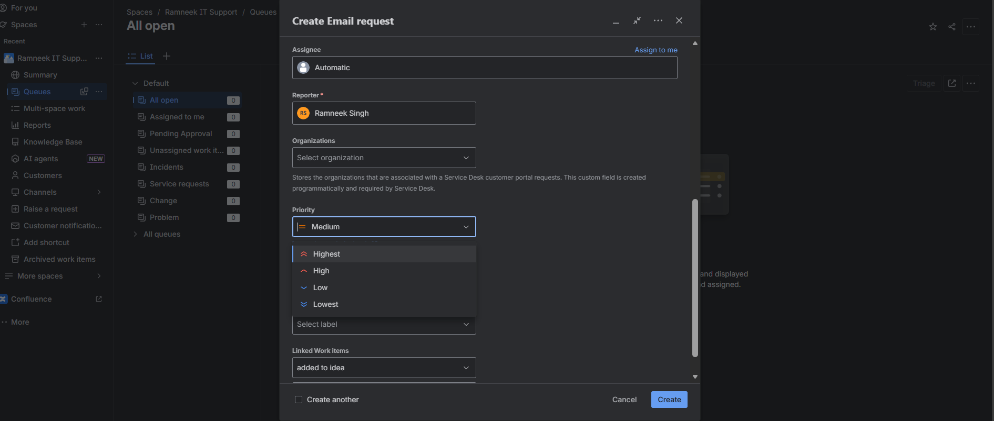
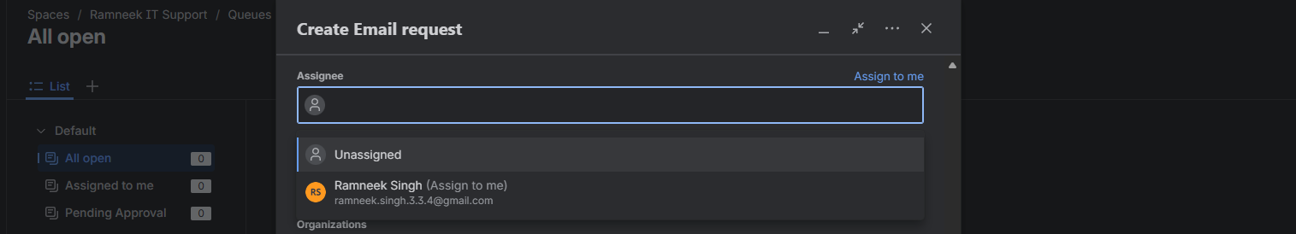
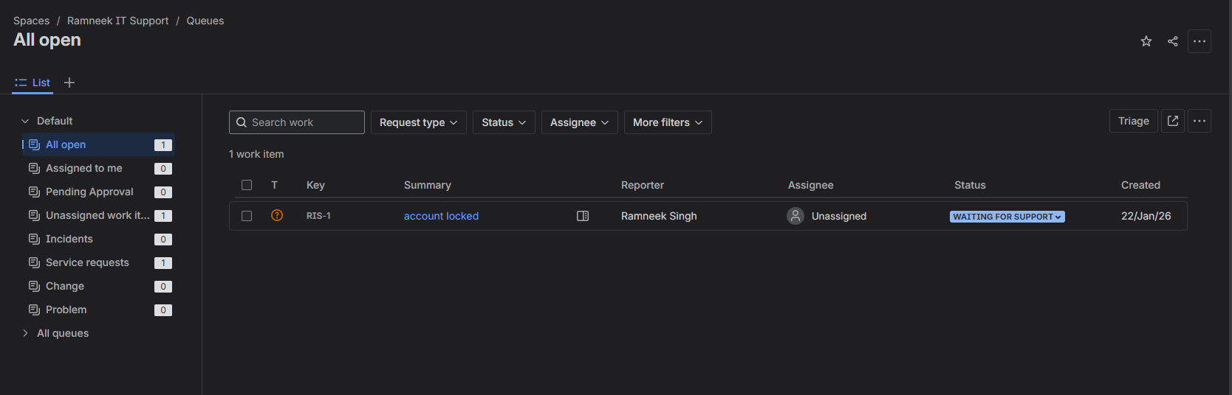

Part 3: Default Workflow
Use Jira’s default workflow:

- Open
- In Progress
- Waiting for Customer
- Resolved / Closed

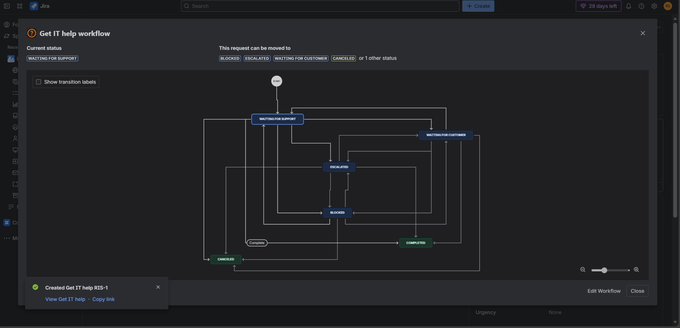

Part 4: Submit Test Tickets in Jira
Create at least 3 test tickets:

- Password reset request
- Laptop not powering on
- VPN connection issue
- For each ticket:
- Set priority
- Assign yourself
- Add description

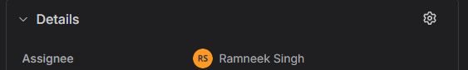
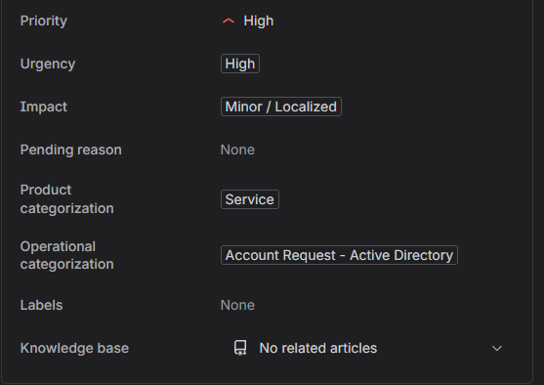

Part 5: Working a Ticket (Technician Flow)
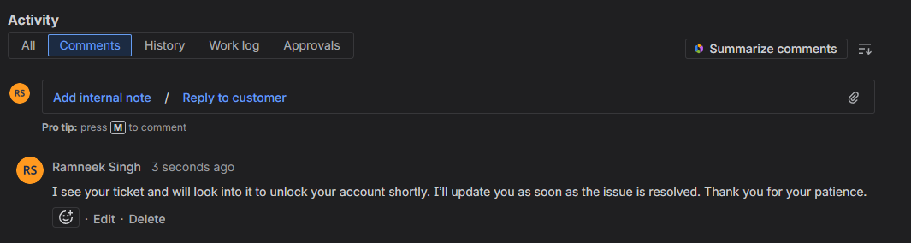
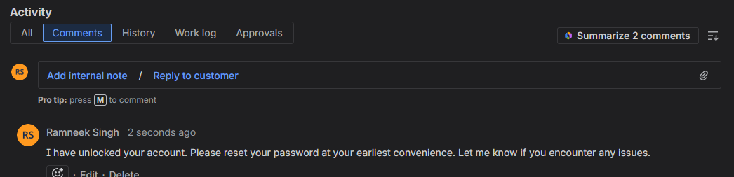


Part 1:Setup & Overview of Spiceworks
In this part, we’re setting up a working ticketing system environment. This includes creating your account, configuring the company profile, adding agents, defining ticket categories and statuses, and adding sample users. By the end, the system will be ready to simulate real IT support workflows.

Step 1: Create a Free Account
- Go to Freshdesk (or Spiceworks Cloud Help Desk).
- Sign up for the free plan.
- Note the portal URL (e.g., yourname.freshdesk.com).
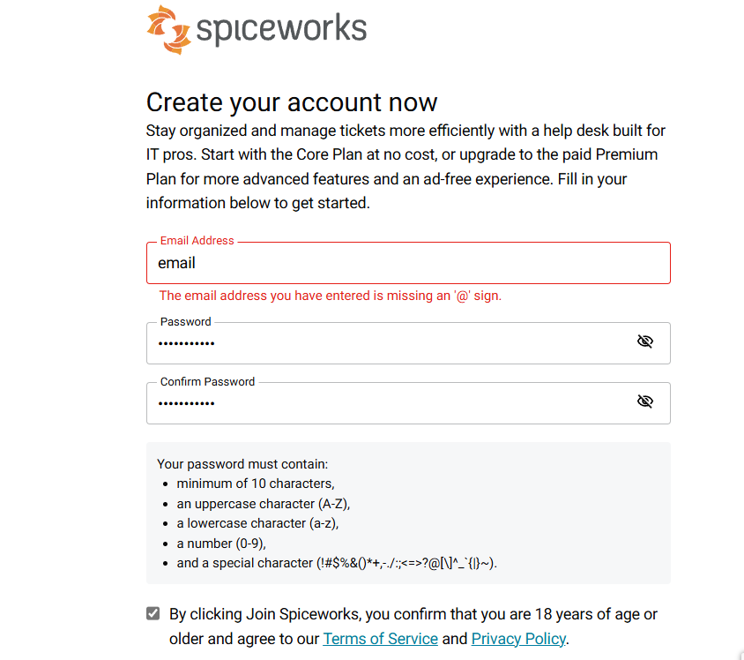

Step 2: Set Up Company Profile
- Add your company name.
- Optionally upload a logo.
- Configure the support email address.
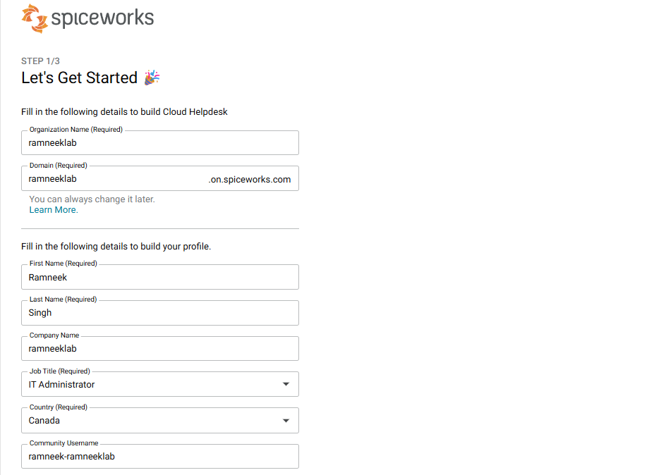
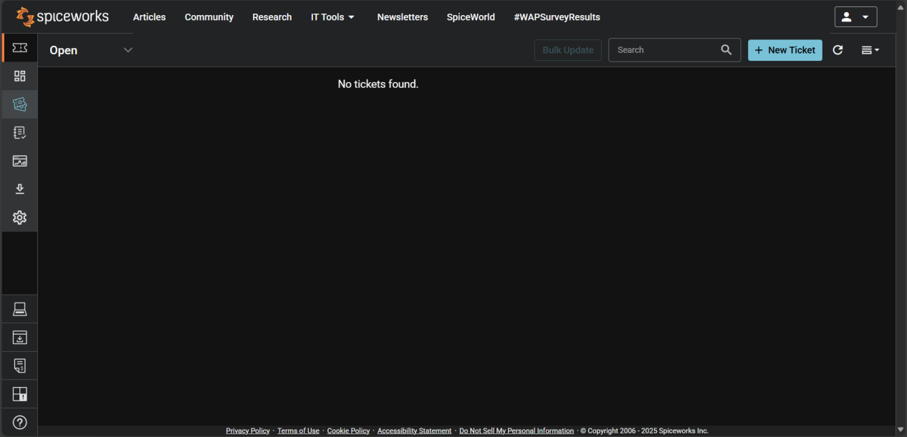

Part 2: Configuration & Settings Overview
This section explores the essential configuration options that define how your help desk operates.

Step 1: Ticket Rules

- Go to Settings → Tciket Rules.
- Create a rule to automatically route or categorize tickets. Example:
- If the subject contains “password,” assign to the IT Support technician.
- If the ticket is from a specific domain (e.g., @ramneeklab.com), mark as “High Priority.”
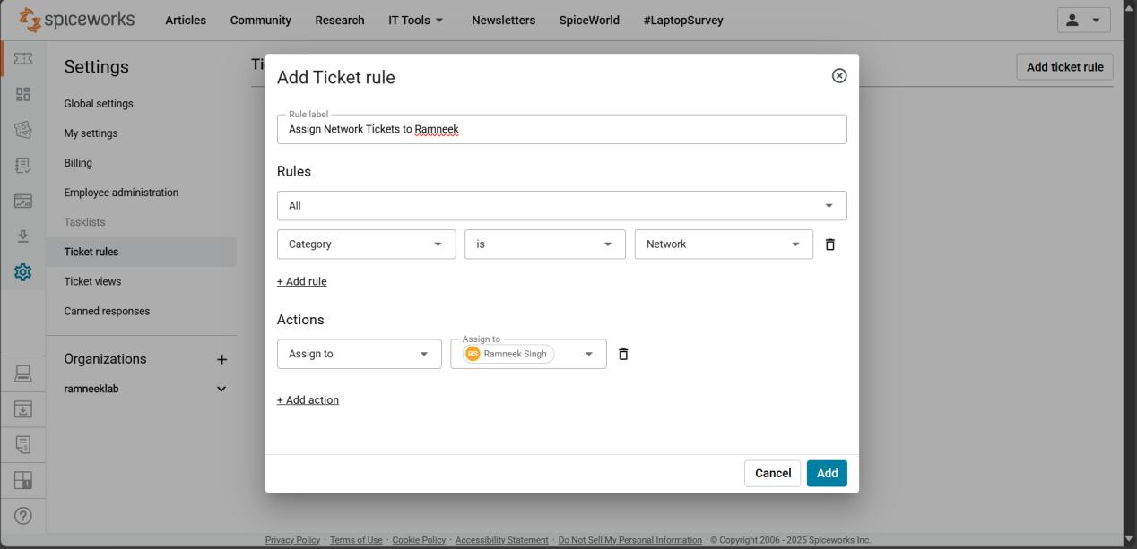

Step 2: Review Other Settings
- Navigate through the following key areas to understand what they do:
- Organizations: Basic info about your company (RamneekLab).
- General: Adjust system defaults such as notifications and display preferences.
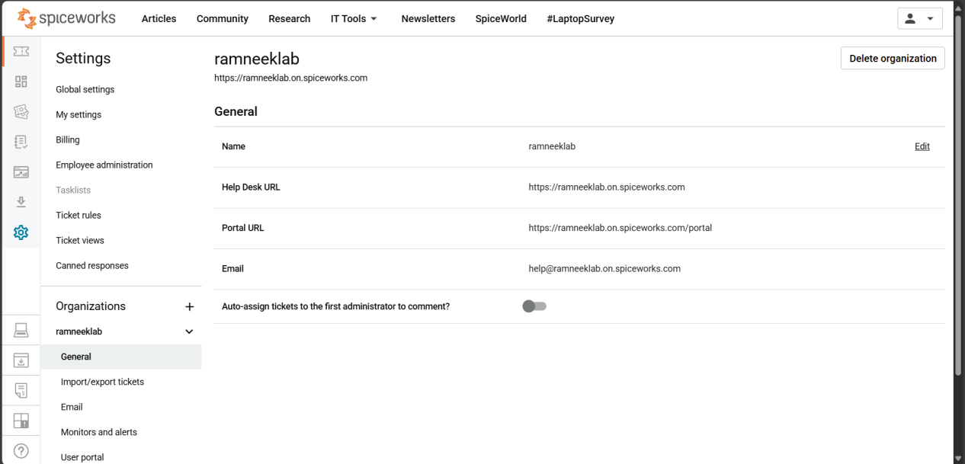
- Import/Export Tickets: Useful for backing up or migrating ticket data.
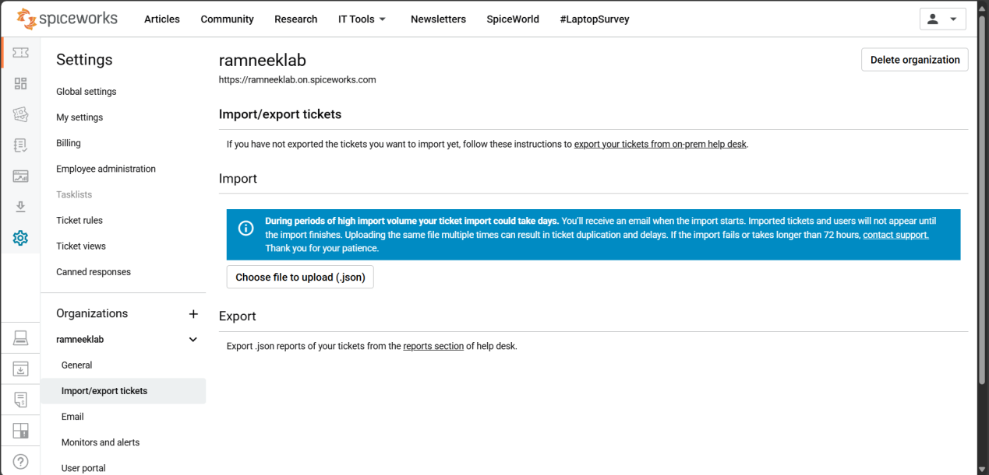
- Email: Configure your support email (e.g., support@ramneeklab.com). This allows users to email directly to create tickets.
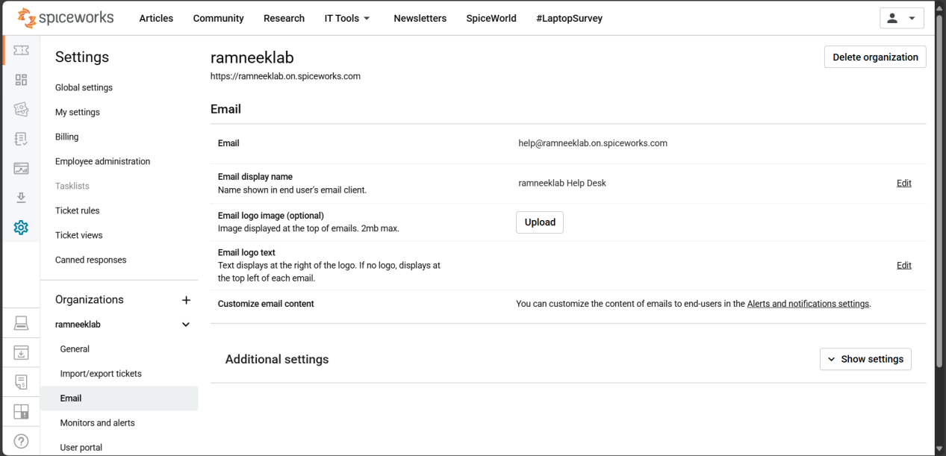
- Monitors and Alerts: Set alerts for new or overdue tickets.
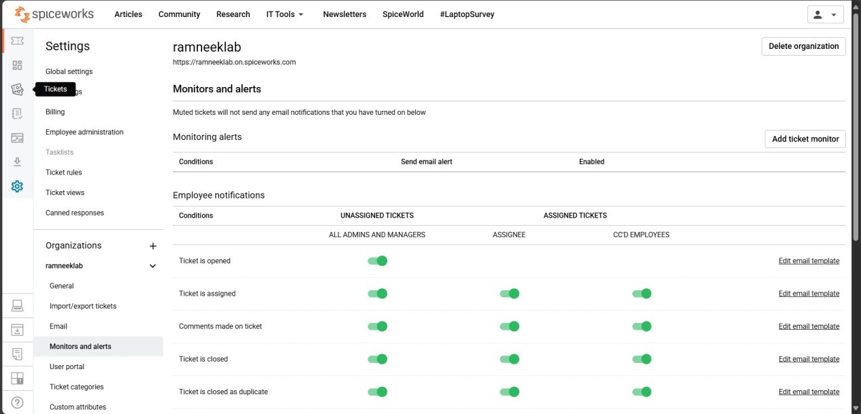
- User Portal: Customize how your users submit and track their requests online.
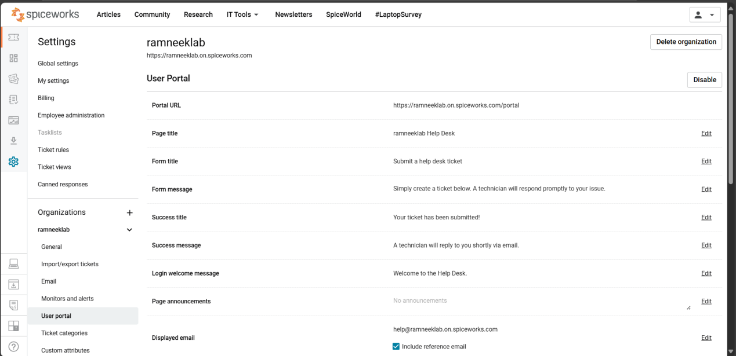
- Ticket Categories: Organize issues into categories like Hardware, Software, Network, etc.
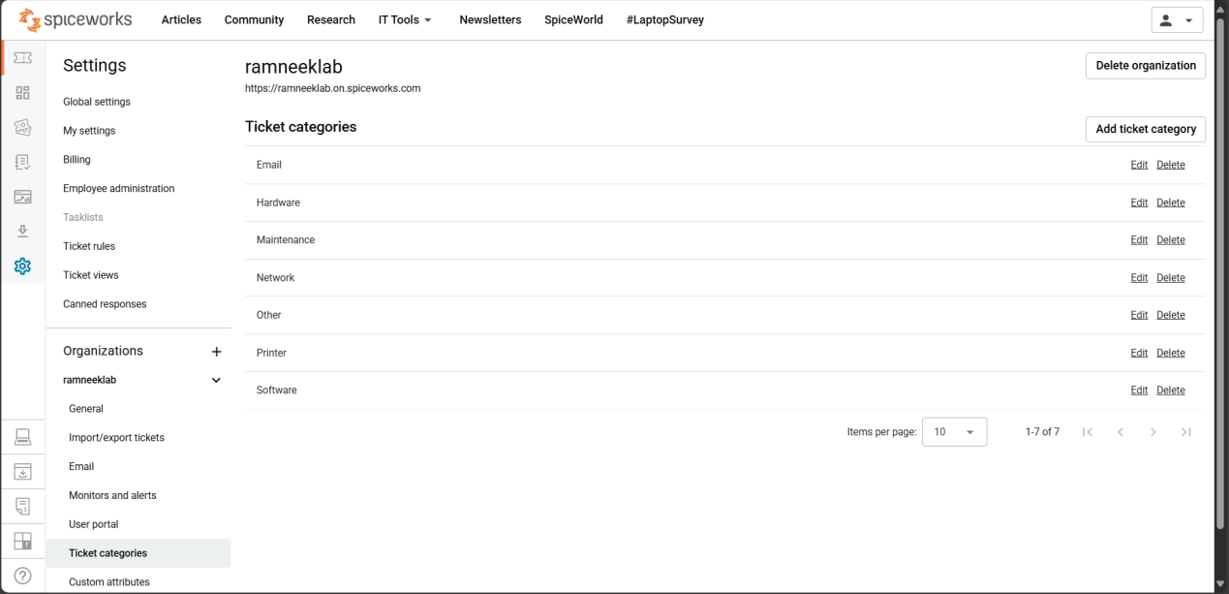
- Custom Attributes: Add extra fields to tickets if needed (e.g., “Department” or “Device Type”).
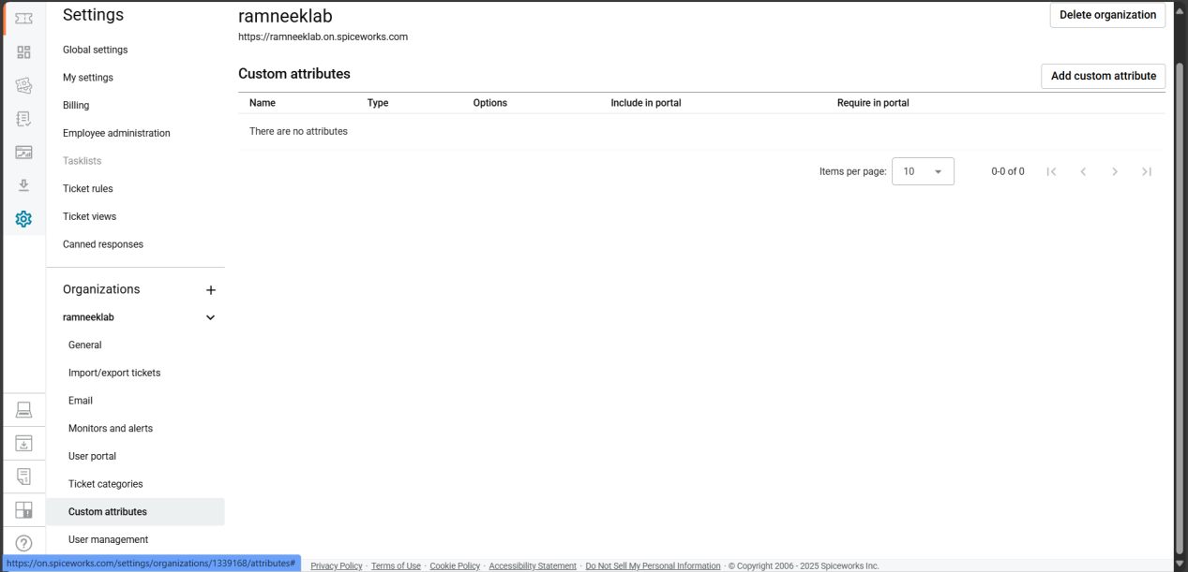
- User Management: View and manage the list of technicians and users who interact with the help desk.
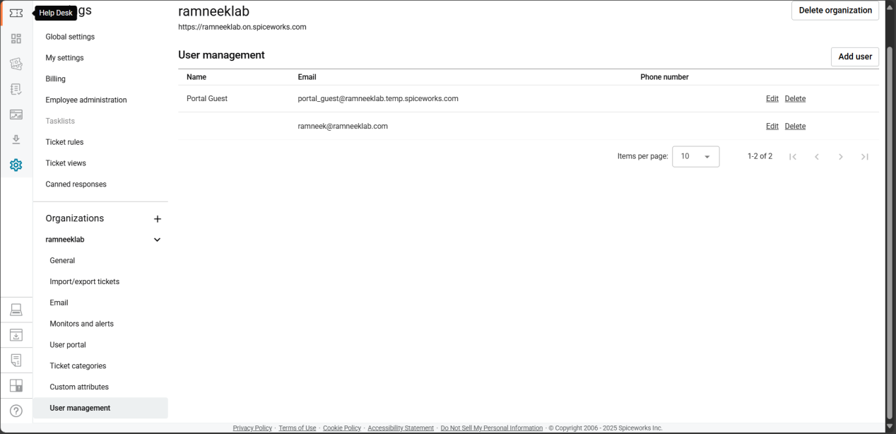
- This section ensures you understand how each part contributes to a smooth ticketing workflow.

Part 3: Submitting Test Tickets

Now that your help desk is configured, it’s time to test different ways users can submit tickets.

Method 1: Email Submission
- Send an email to your support address (example: support@ramneeklab.com).
- The system will automatically generate a ticket.
- Example subject lines:
  - “Laptop won’t boot”
  - “Need access to shared drive”
  - “Wi-Fi not working in lab”
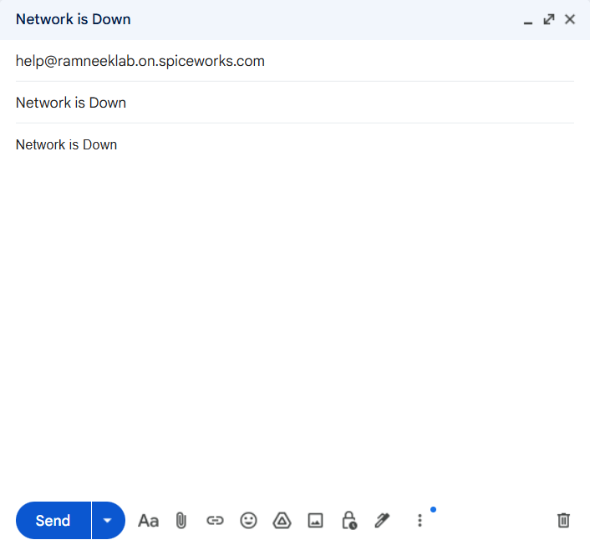
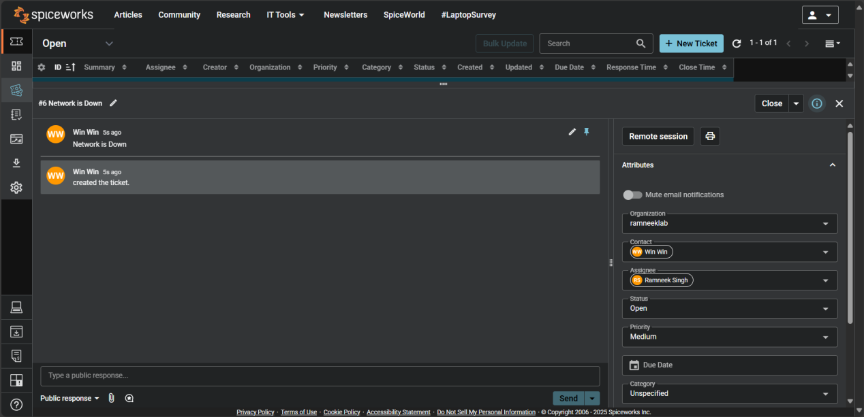
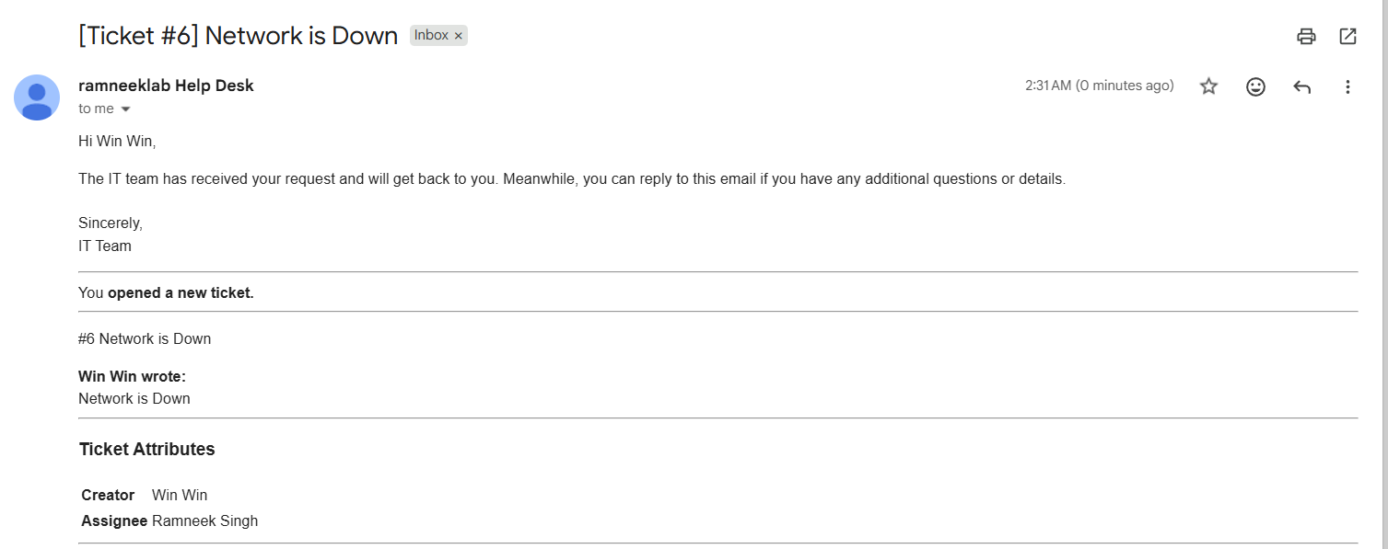
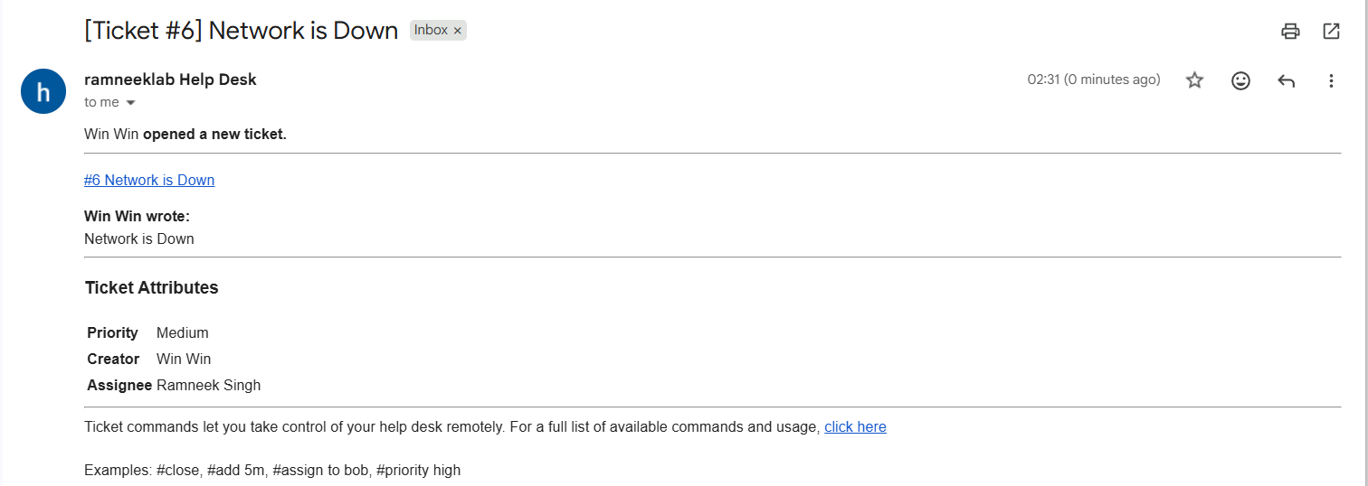

Method 2: User Portal Submission
- Visit your help desk portal (e.g., ramneeklab.spiceworks.helpdesk.com/portal).
- Users can fill out a short form with subject, description, and category.
- The ticket will appear in the dashboard instantly.
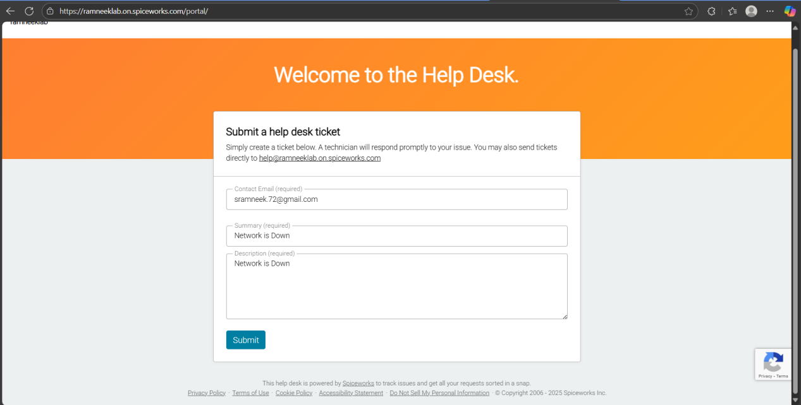
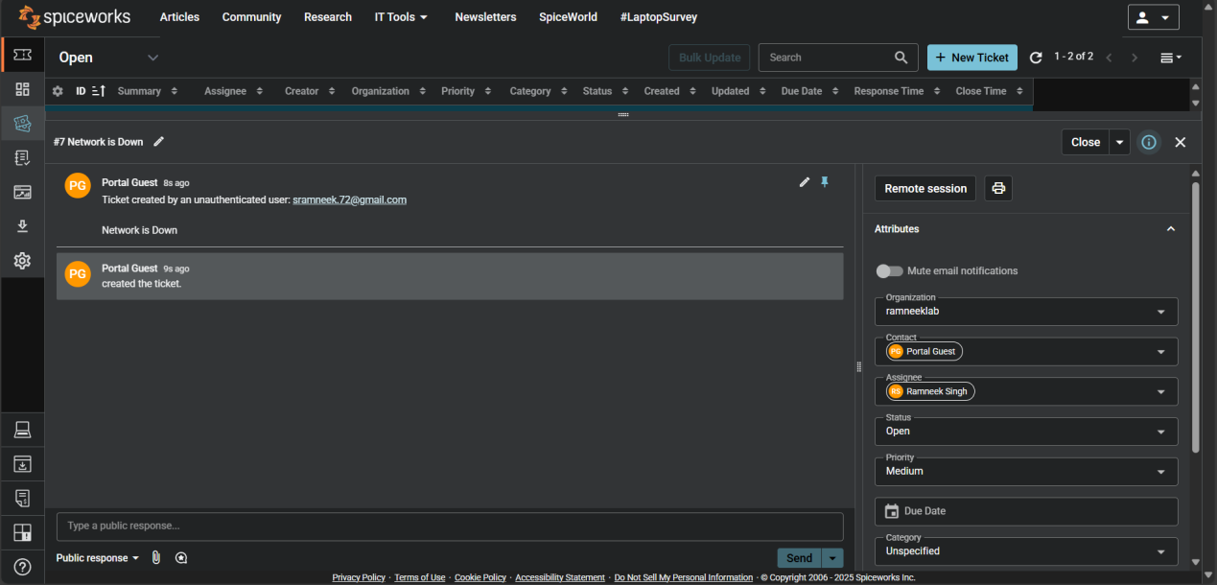

Method 3: Manual Ticket Creation (Technician)
- From your dashboard, click New Ticket.
- Enter the requester’s name, issue details, and category.
- Save the ticket — this is useful when a user calls or messages you directly.
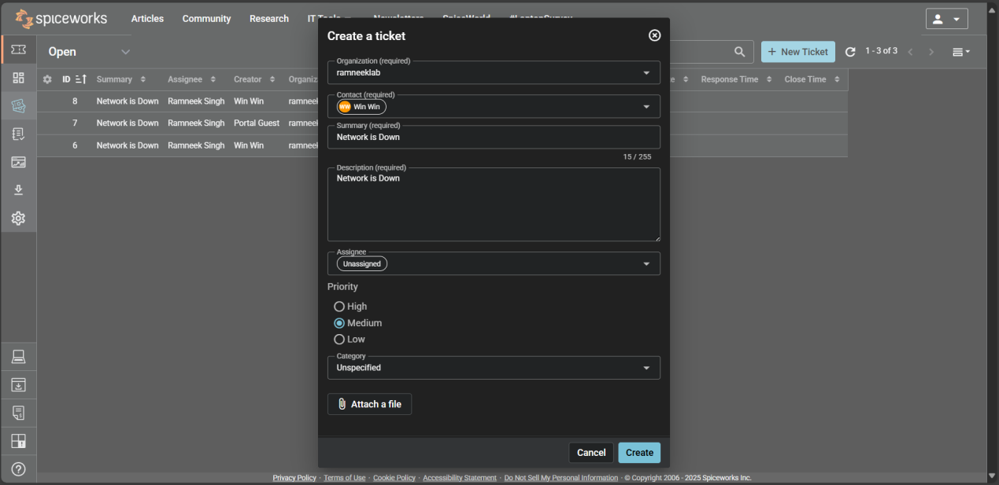
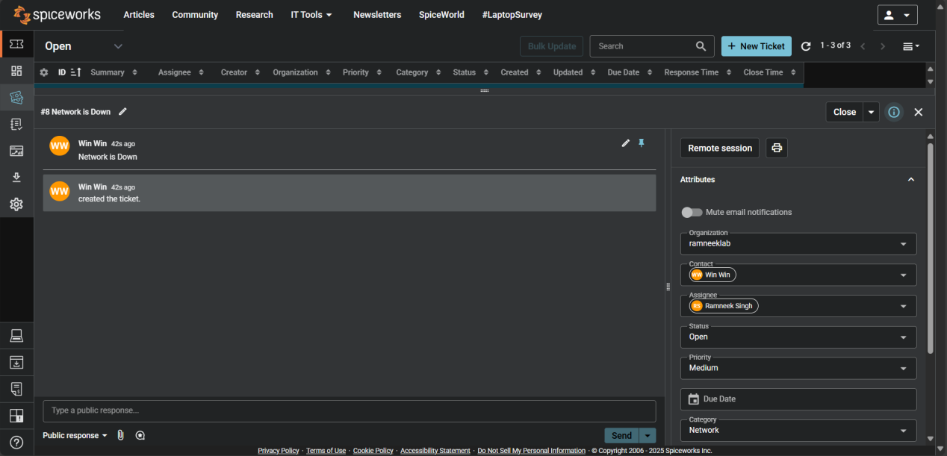

Part 4: Help Desk Technician Guide

This section focuses on how to manage tickets effectively as a help desk technician. You’ll learn the full workflow from ticket creation to resolution.

Step 1: Reviewing and Assigning Tickets
- Open the Tickets tab on your dashboard.
- Click on a ticket to view details.
- Assign it to yourself or another technician if applicable.
- Check the category, priority, and requester info.
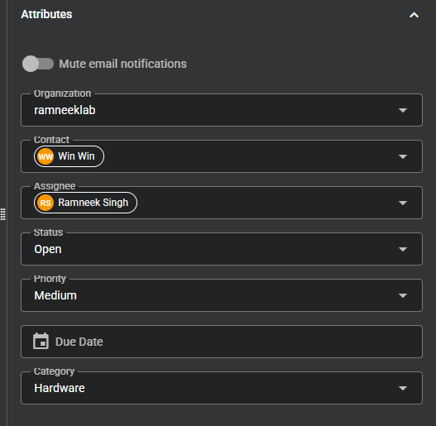

Step 2: Communicating with Users
- Use the Public Reply section to respond to users directly.
- Replies are automatically emailed to the requester.
- Use Private Notes for internal updates visible only to technicians.
- Add attachments or screenshots if needed.
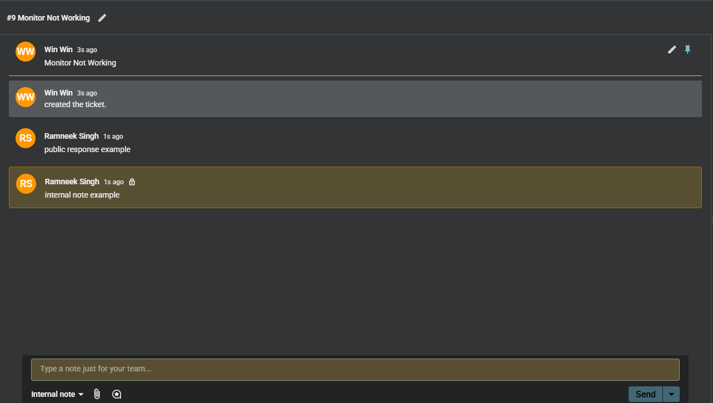

Step 3: Updating Ticket Status and Priority
- Change the ticket status depending on progress:
- Open – New ticket received.
- In Progress – Issue being worked on.
- On Hold – Waiting for user response or external action.
- Closed – Issue resolved.
- Adjust the priority (Low, Medium, High, Critical) based on urgency.
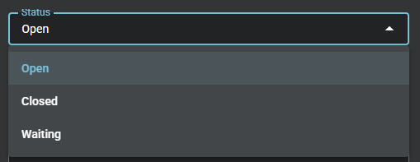
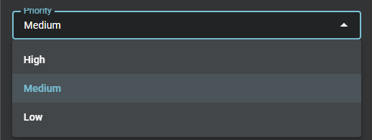

Step 4: Tracking and Reporting
- Use the Dashboard to monitor open and closed tickets.
- Check response times and technician workloads.
- Use reports to analyze trends and common issues.
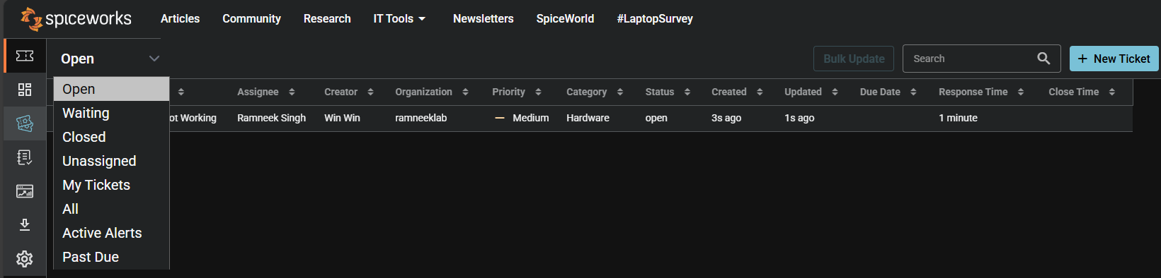
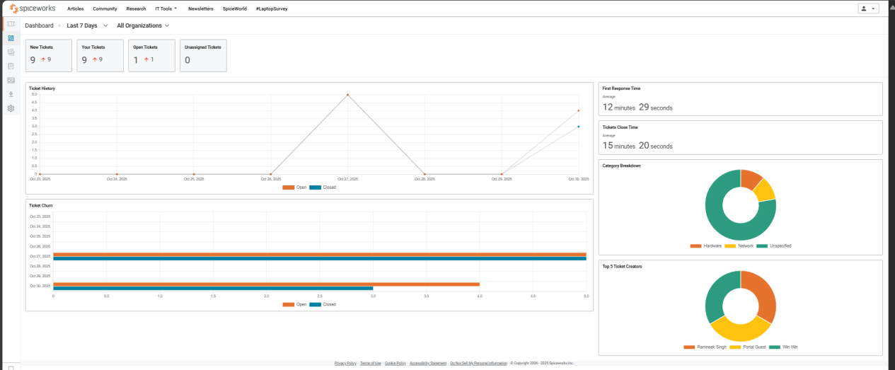

Part 5: Help Desk & Ticket Management Cheat Sheet

Ticket Status
- Open: New ticket received
- In Progress: Actively working
- Waiting: Awaiting user or external action
- Closed: Issue resolved

Priority Levels
- Low: Minor impact
- Medium: Moderate impact
- High: Major impact
- Critical: System-wide or urgent issue

Technician Checklist
- Review ticket details and attachments
- Confirm category and priority
- Communicate with the user
- Document all actions
- Update status and close after confirmation

Troubleshooting Basics
- Hardware: Power, cables, restart → escalate if damaged
- Software: Restart, update, reinstall → escalate if widespread
- Network: Connectivity, ping, restart → escalate if multiple users affected
- Access: Reset password, check permissions → escalate if admin or security-related

Escalate When
- Issue affects multiple users
- Security or access risk exists
- Resolution exceeds role or permissions

Part 6: Wrap-Up & Key Takeaways
This lab demonstrates a complete help desk workflow using Jira Service Management as the primary ticketing system, with additional exposure to Spiceworks and Freshdesk.

- Tickets were handled through the full lifecycle: Open → In Progress → Waiting → Resolved → Closed.
- Issues were categorized, prioritized, documented, and resolved using standard IT support practices.
- Structured troubleshooting was applied across hardware, software, network, and access-related issues.
- Clear communication and proper escalation ensured efficient resolution and user satisfaction.
- Dashboards and queues were used to monitor workload and ticket status.

Key Takeaway:
Understanding ticket workflows, prioritization, documentation, and communication in Jira is essential for effective entry-level IT and help desk roles.

